|  |  |
| --- | --- |
|  |  |
| (b)The water drops in the bag |
|  |
| (a) Cultivation of the rice seedlings by transparent bag | (c) The reflective light |

Figure 1. Captured root system of rice seedlings. The root is in its primitive shape and it clings to the capillary paper.

|  |  |
| --- | --- |
|  |  |
| (a)Automatic imaging darkroom | (b) Image acquisition |

Figure 2 The equipment for collect root image

|  |  |  |
| --- | --- | --- |
|  |  |  |
| (c) The stride of sliding window with different γ |
|  |
|  |
| (a) Root system of single seedling | (b) Mask of the root system | (d) Patches |

Figure 3. Process the root images for CNN training .



Figure 4. The residual module and SE-ResNet module. The residual is scaled by the small branch net. FC means the full connection layer



Figure 5. The structure of our SE-ResUnet

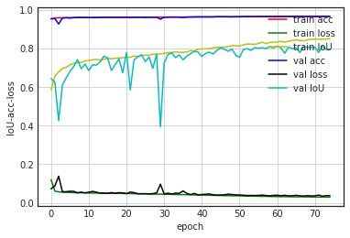

Figure 6. The convergence process on train set and validation set

|  |  |  |  |
| --- | --- | --- | --- |
|  |  |  |  |
|  |  |  |  |
| (a) The lateral root was well segmented | | (b) The root-like noise was romoved | |

Figure 7. The segmentation experiment of proposed model

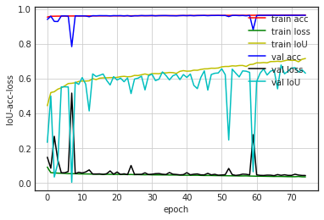

Figure 8. The convergence process of U-net

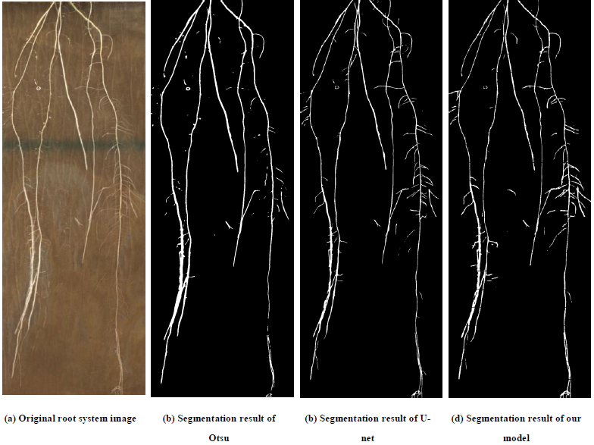

Figure 9. The segmentation comparison between different methods

|  |  |  |  |
| --- | --- | --- | --- |
|  |  |  |  |
| (a) Some root was not segmented | | (b) The noise was segmented as root | |
|  |  |  |  |
| (c) The lateral root is too tiny to segment | | (d) The junction of roots was not well segmented | |

Figure 10. The defects of annotation image(mask)

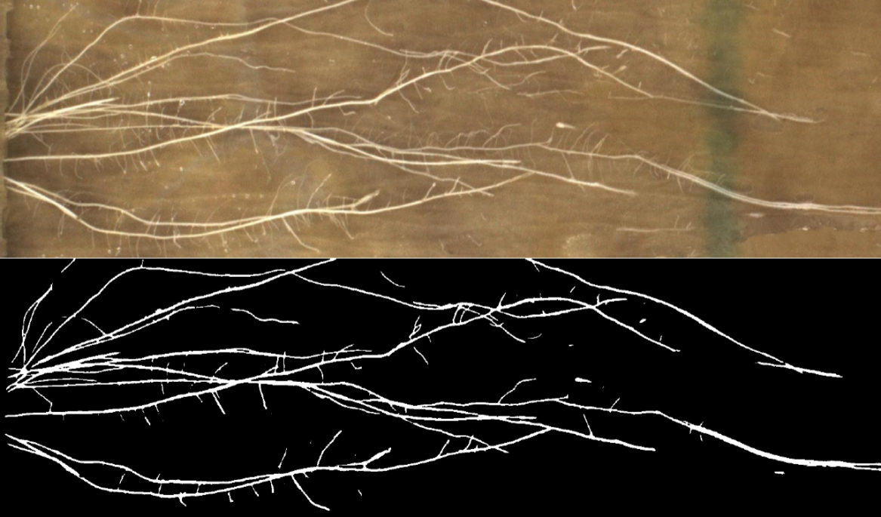

Figure 11. The worst result